

ICL-2011 Visualisation and Graphical Algorithms
TOBY BEEVERS
Cambria ID: 21075206 Bangor ID: 500704883
APPLIED DATA SCIENCE DEGREE APPRENTICESHIP BSC

Contents
Identify a format and design a holding page. 2
Create the web page using HTML, JavaScript and Canvas. 2
Justify your final design 2
Bibliography 2
Glossary 2

1400 words

Identify a format and design a holding page
To effectively display video game sales data over the last 20 years, I will use two complementary visualisations.

Interactive Bar Chart
Bar charts can be effective for visualising time series data when the primary goal is to compare specific values across different periods or categories, rather than focusing on the overall trend. They are particularly useful when comparing discrete segments, such as monthly sales figures or quarterly profits. Additionally, bar charts can highlight significant differences or deviations from the average or trend, making it easier to identify key insights [1].
The Game Sales dataset shows various types (segments) over time, I intend to analysis over a time series and include the following features:
- X-axis: Years (1980–2023)
- Y-axis: Total global sales (in millions)
- Interactive filtering (e.g., toggle between regions: NA, EU, JP, Other)
- Hover effects to display exact sales figures

Pie Chart (for Regional Market Share in a Selected Year)
Pie charts are used for segmentation to visually represent how a whole is divided into parts, showing each part's proportion relative to the entire whole. This is particularly effective when comparing the size of different categories within a dataset. By displaying data as slices of a circle, pie charts allow for a quick understanding of the relative sizes of each segment [2].
The Game Sales dataset shows various types (Segments) over time, I intend to group the types and visualise in a pie charts show proportions of sales contributions, as a whole and filter by a given year. Features will include:
- Dropdown to select a year
- Breakdown of sales by segment (Sales Genre)
- Labels showing percentages

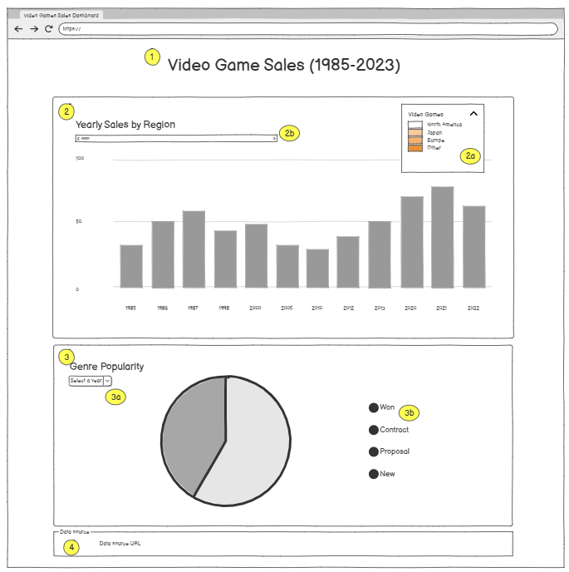
Holding Page Design Mock-up
A single simple, clean HTML page with:
- Header: "Video Game Sales (2003–2023)"
- Bar Chart Section:
  - Select filter by region
  - Horizontal slider to filter out time series
- Pie Chart Section:
  - Year selector dropdown menu
  - Legend for segments, with filter
- Footer: Data source attribution
The use of colours will be an important part of this visualisation to make sure the data is clear and intuitive. I will use various colours to differentiate between categories of data in both the bar chart and pie chart. When using colours, it is also important to show a key, so the user understands the context, I intend to make the key interactive for filtering [3].

Create the web page using HTML, JavaScript and Canvas

HTML Structure
JavaScript Structure

Justify your final design
Justification of Choices
Bar Chart: Best for showing trends over time and comparing different regions.
Pie Chart: Best for highlighting market dominance in a specific year.
Responsive Design: Canvas-based charts scale well across devices.
Interactivity: Users can explore data dynamically, improving engagement.

Stacked Bar Chart: Best for comparing total sales across years while showing regional breakdowns.
Doughnut Chart: Better than pie chart for readability; shows genre dominance clearly.
Responsive: Works on mobile/desktop.
Interactivity: Users can explore data dynamically.

Bibliography
[1] np., ‘Bar charts’, Analysis Function. Accessed: Apr. 28, 2025. [Online]. Available: https://analysisfunction.civilservice.gov.uk/support/communicating-analysis/introduction-to-data-visualisation-e-learning/module-5-bar-charts/
[2] np., ‘Pie Charts’, Analysis Function. Accessed: Apr. 28, 2025. [Online]. Available: https://analysisfunction.civilservice.gov.uk/support/communicating-analysis/introduction-to-data-visualisation-e-learning/module-9-pie-charts/
[3] ONS, ‘Using colours in charts’, ONS Service Manual. Accessed: Apr. 28, 2025. [Online]. Available: https://service-manual.ons.gov.uk/data-visualisation/colours/using-colours-in-charts#:~:text=with%20an%20order-,Overview,highlight%20data%20within%20a%20chart.

Glossary
HTML Code – index.html
Java Script Code – script.js

